Much Disturbance with Abolitionists:
Abolitionist Activities in Missouri

A Curriculum for Students

Sponsored by


“We have much disturbance with abolitionists. Some have been ordered to leave the county which they have done. The Reverend D. Nelson I believe has gone to Illinois.”

Letter from Dr. William McPheeters, of Palmyra, Missouri to Margaret Bell, of Bowling Green, Missouri. June 12, 1836.

Abolitionists worked to end slavery.
William McPheeters and his brother Samuel came to Missouri from Virginia. William became a medical doctor in St. Louis. Samuel became a Presbyterian minister. He had connections to Marion College, a Presbyterian school in Palmyra which trained ministers. Its founder, Rev. David Nelson, became a leading abolitionist.
Dr. William McPheeters joined the Confederate Army. He was the chief surgeon for Confederate General Sterling Price. Samuel continued to preach in Missouri during the Civil War. He was suspected by the Union Army of being in sympathy with the Confederates. After the war, Dr. McPheeters reopened his practice in St. Louis and became a leader of the Missouri Medical Association. He eventually retired to St. Louis County.
Photo from the McPheeters Papers, Missouri Historical Society Research Center
St. Louis

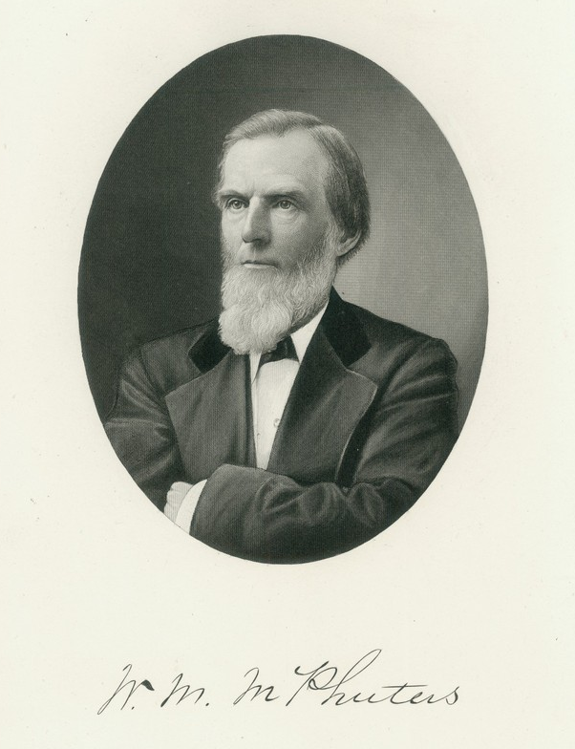
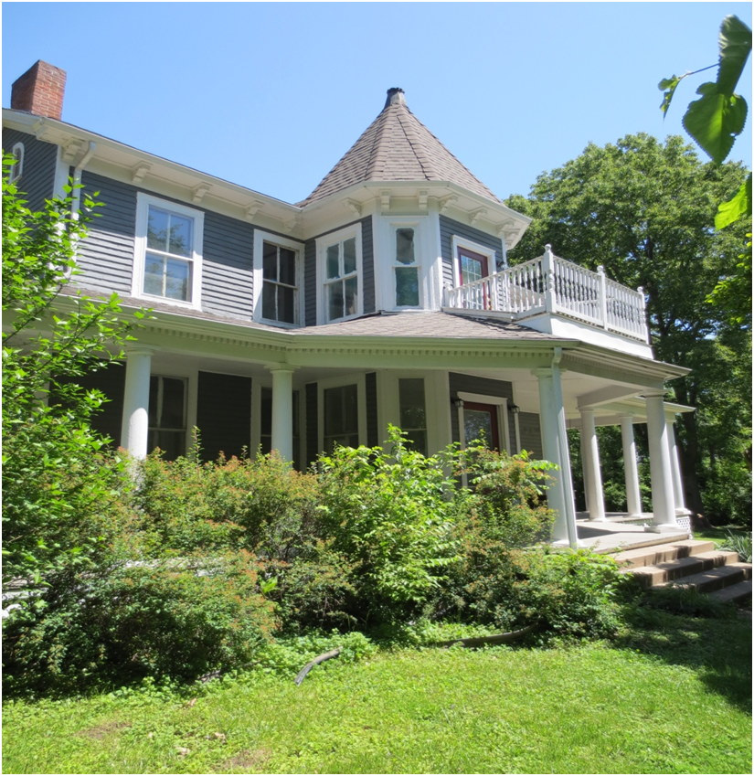
From The McPheeters Papers at the Missouri Historical Society Research Center - St. Louis
The house in St. Louis County where Dr. McPheeters and his wife spent the last years of their lives.
Introduction
The materials in this curriculum were designed for use with students in grades 4 through 12. Each unit consists of a student reading followed by one or more activities to engage the students with the content of the reading. The goal is to introduce the students to the abolitionists who sought freedom for the 114,000 enslaved persons in Missouri during the years before the Civil War. The curriculum builds upon material presented in Cecilia Nadal’s play “An Amazing Story: German Abolitionists of Missouri” developed for Cross Cultural Strategies, Inc.

Topics of the Readings
Reading One: Enslaved persons in Missouri
Reading Two: Early Missouri Abolitionists
Reading Three: Free African-Americans and the Abolitionist Cause
Reading Four: German Abolitionists and the Power of the Press
Reading Five: The Underground Railroad in Missouri

Authors
Dr. Gary McKiddy is a past president of the Missouri Council for History Education. He has a doctorate in History Education from Illinois State University and over 45 years of teaching experience.
Francine Davis, NBCT, retired from teaching 32 years in middle school and high school history classrooms. She is a board member of the Missouri Council for History Education.

The authors wish to thank the following for assisting in gather information for this project: Dorris Keeven-Franke, Director of the Missouri German Consortium; A.J. Medlock, Senior Archivist, State Historical Society of Missouri – St. Louis; the staff of the Missouri Historical Society’s Research Center; and the staff of the St. Louis City-County Library’s Local History Research Center.
READING I
Enslaved Persons in Missouri

Abolitionist: a person who opposed the practice of the enslavement of other people.

Soon after Europeans began to settle the Upper Louisiana Territory (which included Missouri), they began to import enslaved persons. As early as 1712, French merchants began importing slaves to work in the lead mines near Potosi. Slavery was an accepted part of life on the edge of the wilderness under French, Spanish and then American control. When the U.S. purchased the Louisiana territory in 1804, almost 1,200 enslaved persons lived inside the borders of present-day Missouri. By the start of the Civil War in 1861, that number had risen to over 114,000!
In 1818, the issue of slavery had almost prevented Missouri from becoming a state. Geographically, it was a northern state and should have been become a free state. But many settlers had brought their slaves from Kentucky, Tennessee, and Virginia and refused to release them. So in 1820 the Missouri Compromise allowed Missouri to enter the Union as a slave state, while the state of Maine entered as a free state. In this way, the number of Senators from free and slave states could remain balanced.
In the southern states many enslaved people lived on plantations holding over 500 slaves. In Missouri only a few plantations had over 150 slaves. Most had fewer than 20. In Missouri, enslaved persons farmed hemp (used to make rope for ships), farmed tobacco, and raised hogs. Some cotton was grown in the flat river bottoms along the Mississippi and Missouri Rivers. Some enslaved persons were house servants. Others were trained as craftsmen and women and then rented out by their owners.
The Missouri Territorial and early State Legislatures passed laws designed to prevent owners from mistreating their slaves. Because Blacks were not allowed to testify in court against Whites, the laws were not enforced. Trying to force an owner to fulfill the law could also result in an enslaved person being “sold down the river” to a large plantation in Mississippi or Louisiana. Conditions there were usually even more brutal. Family members would never be seen again.
As an enslaved person, you were the property of the owner and could be sold at any time. If you were a woman, your children were considered enslaved and could be sold without your permission. When the slave owner died, their slaves were divided among relatives or sold to pay debts.
As the number of slaves in Missouri rose, owners became more and more fearful of a possible slave revolt. Local and state laws were passed to prevent slaves from cooperating in a possible slave revolt. Laws prevented enslaved children from being taught to read or write. Slaves were prohibited from gathering in groups such as churches or restaurants without the supervision of a White person. In some towns, Blacks (both enslaved and free) were prohibited from being in town after dark.
In Missouri, free Blacks were required to purchase a permit to live in a county. They also had to give a (cash) bond to the sheriff to guarantee their good behavior. In some areas, they were not allowed to own property or even have a bank account.
When the federal government passed the Fugitive Slave Law in 1850, it became a federal crime to assist enslaved people who escaped. Many Americans had come to oppose owning slaves. The Underground Railroad began to help enslaved people escape and find their way to Canada or Mexico. Societies formed in the New England states to help former slaves and free-born black people move to Africa.
During the 1850s, the debate over slavery in Missouri continued. Slave owners defended the right to own slaves. They argued that they could not afford to produce crops without cheap labor. Many of them had most of their wealth invested in the slaves they owned. Other people argued that slavery was immoral on religious and ethical grounds. Conflict became more violent as the national debate led to the Civil War in 1861. Missouri became a divided state with representatives in both the Federal and Confederate Congresses.

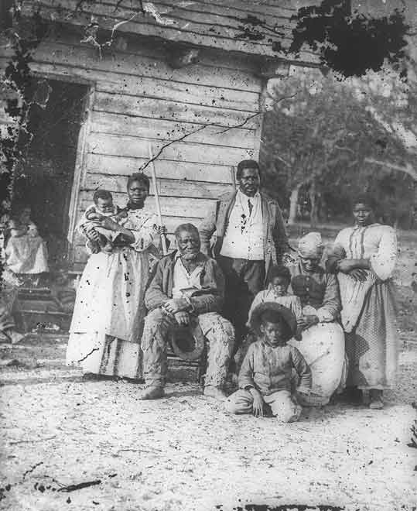
An enslaved family in front of their cabin.

While enslaved persons could not vote, they were counted toward the number of total people in a state to determine how many representatives a state got in the Federal House of Representatives. From 1790 to 1850, they were added in with the total population.
In 1850 and 1860, the Federal Government did a separate Census (when the government counts the people in the country every ten years). The names of individual slaves were seldom given, they were listed by age group and sex under the names of their owners.

STUDENT ACTIVITIES I

1. Using the Reading, compose a paragraph that lists Missouri laws before the Civil War that applied to Black people but did not apply to White people.
2. Read the two deeds recording the sale of enslaved persons in St. Charles County. Since enslaved persons were valuable property, their sales were recorded in the county where they took place. After reading the documents, answer these questions:
1. WHO
Who was the seller?
Who was the purchaser?
Who was sold?
2. WHAT
What was done?
What money changed hands?
3. WHERE did it happen?

4. WHEN did it happen?

5. WHY might this event have happened? [Make an educated guess on the reasons why the enslaved persons were being sold or what the laws were in Missouri.]

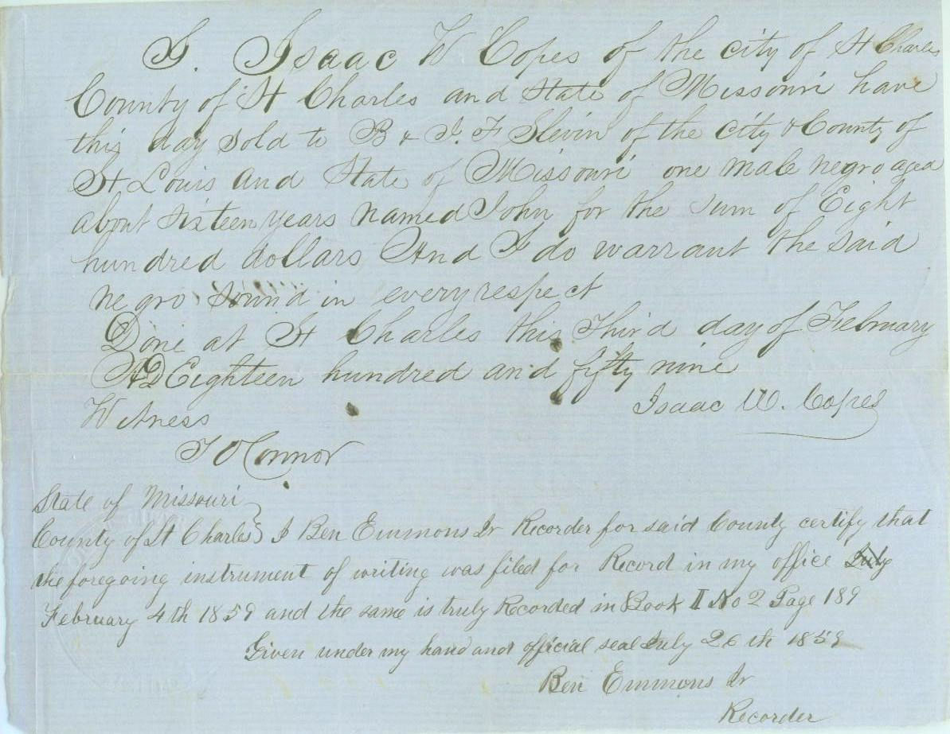

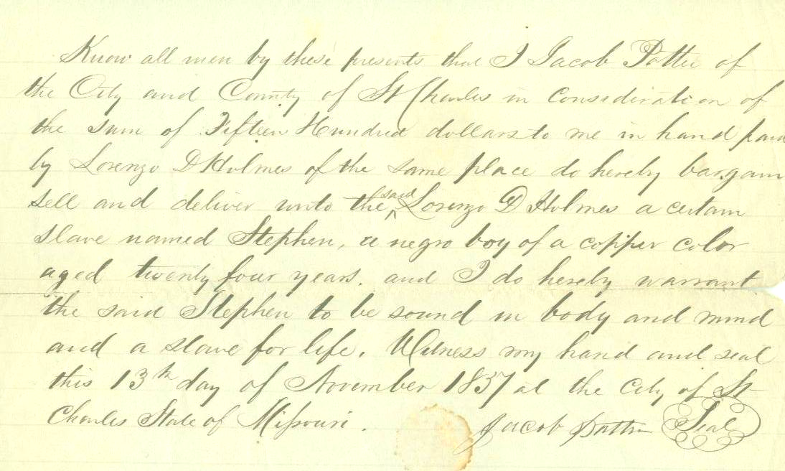

I Isaac W. Copes of the City of St. Charles, County of St. Charles in the state of Missouri have this day sold to B. and I.F. Slavin of the city and County of St. Louis and state of Missouri one male Negro aged about sixteen for the sum of eight hundred dollars and I do warrant the said Negro sound in every respect.
Done at St. Charles this third day of February A.D. Eighteen hundred and fifty nine.
Isaac W. Copes
Thomas OConnor
State of Missouri
County of St. Charles I Ben Emmons Jr. Recorder for said county certify that the foregoing instrument of writing was filed for Record in my office duly February 4th 1859 is truly recorded in Book I No. 2 Page 189
Given under my hand and official seal duly July 26th 1859
Ben Emmons Jr.
Recorder

Know all men by these present that I Jacob Potter of the City and County of St. Charles in consideration of the sum of fifteen hundred dollars to me in hand from Lorenzo D. Holmes of the same place do hereby bargain, sell and deliver unto the said Lorenzo D. Holmes a certain slave named Stephen, a negro boy of a copper color aged twenty four years and I do hereby warrant the said Stephen to be sound of body and mind and a slave for life.
Witness my hand and seal this 13th day of November 1837 at the City of St. Charles State of Missouri
Jacob Potter

3. Label a timeline that you create from events described in Reading I.
Place these events beside their correct years:

Louisiana Purchase 1865 Civil War Ends
Fugitive Slave Act
German Immigrants Arrive [1834]
Missouri Compromise
Civil War Begins
Civil War Ends [1865]

READING II
Early Abolitionists in Missouri

One Abolitionist who received coverage in the national press was Elijah Lovejoy. Born in Maine, Lovejoy became a Presbyterian minister and newspaper editor. In 1832, he became an abolitionist after attending a sermon in St. Louis given by the Reverend Doctor David Nelson, a Presbyterian minister and abolitionist. Nelson had founded a college in Marion County north of Hannibal.
Lovejoy’s paper, the St. Louis Observer, published articles opposing slavery. Lovejoy then became a target of supporters of slavery. In 1836, a mob destroyed his printing office and destroyed his press. Lovejoy had to flee to safety in Illinois. He then opened a newspaper there.
Despite threats of violence against him, he crossed the Mississippi River to Missouri to meet with abolitionists and preach anti-slavery sermons at Presbyterian churches. In 1837, he traveled to St. Charles, Missouri, to preach at its Presbyterian Church and to visit his mother and father-in-law. His father-in-law was a professor at St. Charles College. Following his sermon, Lovejoy had gone to spend the night with his in-laws. A mob of pro-slavery men attacked the building in which his in-laws lived on the second floor. They dragged Lovejoy down the steps with the intent of hanging him. His life was saved when Col. George Sibley, whose wife founded Lindenwood University in St. Charles, arrived to rescue him. Sibley and his friends escorted Lovejoy to the Mississippi River. They made sure he safely crossed to Alton, Illinois. Col. Sibley was a Presbyterian who sided with the abolitionists. In 1844, he personally paid for the slaves of Thomas Lindsay of Missouri to travel to Washington, D.C., and from there immigrate to Liberia in Africa. The cost of this trip was almost $650. That was more than most people earned in a year at that time.
In Alton, Lovejoy continued to publish his abolitionist paper. It was smuggled across the river and distributed in Missouri. His life was cut short later that year, when another mob attacked his printing press in Illinois. As Lovejoy attempted to stop the mob from throwing parts of his press into the river, he was shot and killed. Lovejoy’s death was reported in newspapers in most of the Free states in the northern United States.
Two women in St. Charles assisted the abolitionist cause by ignoring the local laws which forbid teaching Black children to read and write. One was a French nun, Rose Philippine Duchene, who came from France in 1818 to educate Native American children. She established a school in St. Charles which educated daughters of the early French settlers, Native American girls, and Black girls, including slaves. Catherine Collier established a school and Methodist church in St. Charles. Both Mother Duchene and Catherine Collier argued that being able to read and write was necessary for the girls to become good Christians and later mothers who could help their children learn to read and write. Mrs. Collier taught the girls religion and hired many of them to make clothing. Her sons sold the clothing as they traveled through the middle and western parts of Missouri.
An early abolitionist in St. Louis was William Greenleaf Eliot. He came to Missouri in 1834 after graduating from Harvard. He started Eliot Seminary, which later became Washington University. He also started Mary Institute, a school for girls, plus the first Unitarian congregation in Missouri. His church provided help for the poor, a vocational school for poor girls which taught sewing, and a school for Black children. During the early years of the Civil War, Eliot helped an escaped slave named Archer Alexander. He then tried to purchase Archer’s wife and children from their owner in St. Charles County. Eliot even appealed to the Union Army and went to court to try to obtain their release. They finally escaped from St. Charles with the aid of a German farmer who hid them in his wagon. Eliot then helped them settle in St. Louis and used his influence to keep them from being returned to their owner.
Abolitionist societies and churches existed across the state. In St. Louis, they financed the famous Dred Scott Case which went all the way to the U.S. Supreme Court. In Chillicothe, the Rev. David White was forced to leave town after supporting abolition. In Parkville, newspaper owner George Park published anti-slavery articles. Even Missouri’s first U.S. Senator, Thomas Hart Benton, came to oppose slavery. The abolitionist movement gained support from many elements of society. Support came from ministers and their churches and also from Free Blacks. Support also came from German immigrants after their arrival in the 1830s and 1840s.

STUDENT ACTIVITIES II

This cartoon which appeared in Missouri concerning the adoption of Missouri's first constitution which allowed slavery. An editorial "cartoon" expresses the opinion of the artist about a current political event.
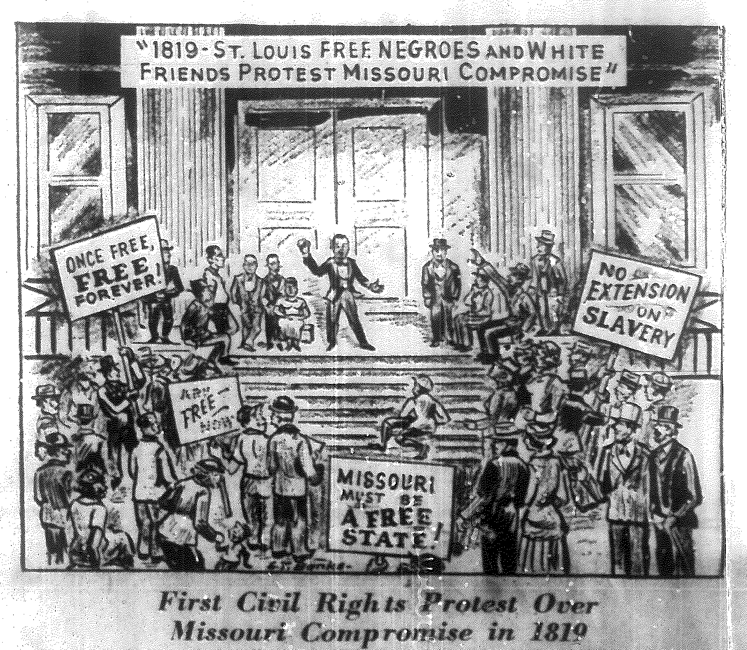

1. Create a chart that shows at least 4 images in the above cartoon. Explain in complete sentences what each image represents.
2. Draw an editorial cartoon that might have appeared in a Missouri newspaper between 1821 and 1865. It could be about the:
- practice of allowing Missourians to own enslaved persons.
- actions of an abolitionist in the Reading.
- effect of slavery on the outbreak of a Civil War.

STUDENT READING III
African-Americans and the Abolitionist Cause

During the early years of statehood, Missouri attracted Free Blacks from the east who supported the abolition of slaves. Having been enslaved themselves or having seen the mistreatment of enslaved persons in the southern states, they wanted to bring freedom to their fellow African-Americans. Some operated within the laws by buying slaves and then emancipating (freeing) them. Others went outside the law by helping slaves from Missouri escape to the Free states of Iowa and Illinois.
John Meachum was a former slave who became a leading abolitionist in Missouri. Born into slavery in Virginia, Meachum learned carpentry, cabinetmaking, and coopering (the craft of making barrels). His owner hired him out and allowed Meachum to keep part of his wages. Those saved wages eventually allowed Meachum to purchase his freedom. Around 1815, John moved to St. Louis to be near his wife Mary, who was an enslaved person. John raised enough money to purchase Mary. He started the first Black Baptist Church west of the Mississippi River. His early congregation included almost 300 people. 200 of the members were enslaved persons.
As with William Greenleaf Eliot, Mother Duchesne, and Mrs. Collier, Meachum’s church included a school for African-American children. By the 1840s, his school was educating over 300 children. It only charged $1.00 for tuition. Then in 1847 the Missouri state legislature banned schools for Black children. So Meachum converted a steamboat he owned into a floating school. It picked up the children at the dock and then floated to the middle of the Mississippi River, which was federal territory. After each day’s classes were finished, the boat returned to Missouri soil. By doing this, he was not in violation of Missouri law.
Mary Meachum was also involved with helping slaves escape to Illinois. The site of her home has been recognized as a stop of the Underground Railroad by the National Park Service.
While Meachum was operating his church and school in St. Louis, a mulatto woman was helping emancipate (free) enslaved people in St. Charles. Sina Simmons came to St. Charles from New Orleans with a considerable amount of money. She was able to buy property that made her one of the largest landlords in the city. She used money received from renting her property to buy slave children at the auctions held on the steps of the county courthouse, just blocks from her home. Like Meachum, she made sure each of the young people she purchased received training. Like Meachum, they were hired out and allowed to keep part of their wages. She came to be known as Aunt Sina. As these young people turned 17 or 18, Aunt Sina allowed them to purchase their freedom. The money she received was then used to purchase other enslaved children who would also eventually become free. By the time of her death in 1853, there were many free African-Americans in Missouri who had adopted the last name of Simmons in honor of the woman who had freed them.
The Reverend Absolom White also lived in St. Charles. Reverend White established a branch of the newly formed African Episcopal Methodist Church in a building which had been left to his congregation in a will. To guarantee that the church would operate within the laws of Missouri, the actual deed was held by the White Trinity Episcopal Church and its vestry guaranteed that they would supervise the church services. During the early years of the Civil War, Reverend White rode through the county conducting church services for African-Americans, both free and enslaved. When he was waylaid by pro-slavery men and hanged, the event was reported by national papers such as Leslie’s Weekly, published in New York.
Back in St. Louis, some African American abolitionists ignored Missouri laws in an attempt to obtain freedom for others of their race. In 1857, 21-year old Ms. Eliza Sly was convicted of “Enticing a Slave to Escape.” She was willing to risk her freedom for the abolitionist cause. Her case appeared before a Grand Jury on May 12. By May19, she had been tried and convicted. She then appeared before Judge J.R. Lackland who sentenced her to seven years in the state penitentiary in Jefferson City. After only eight months she received a pardon from Missouri Governor Steward, conditional upon her leaving the state upon release. Eliza Sly was the only African-American woman imprisoned in the Missouri State Penitentiary for anti-slavery activities.
The list of male African-Americans in the State Penitentiary for anti-slavery activities included John Johnson, Isaac Johnson, George Allen Pinks, and Benjamin Savage, who was sentenced to ten years.
The abolitionist efforts in Missouri were financially supported by a number of anti-slavery groups and individuals in the Free states of the Northeast. One of these individuals was William Wells Brown. Born a slave in Kentucky, he had been brought to St. Louis and was rented out to work on riverboats. In 1834 at age 19, he escaped while the boat upon which he was working was docked in Ohio. He worked his way north and obtained an education. He became a passionate speaker for the abolitionist cause. Just a decade after his escape, he was invited by anti-slavery groups in England to speak there. Money made from this speaking tour and from the narrative he published about his life as a slave helped others obtain their freedom.

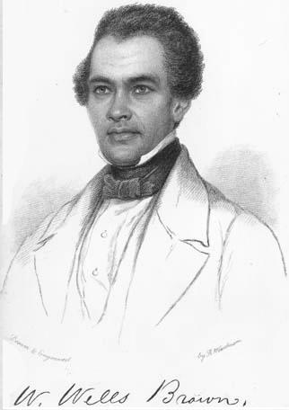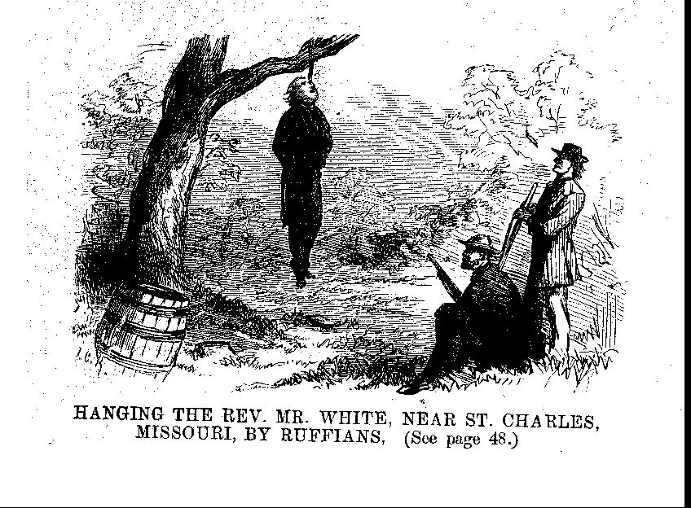

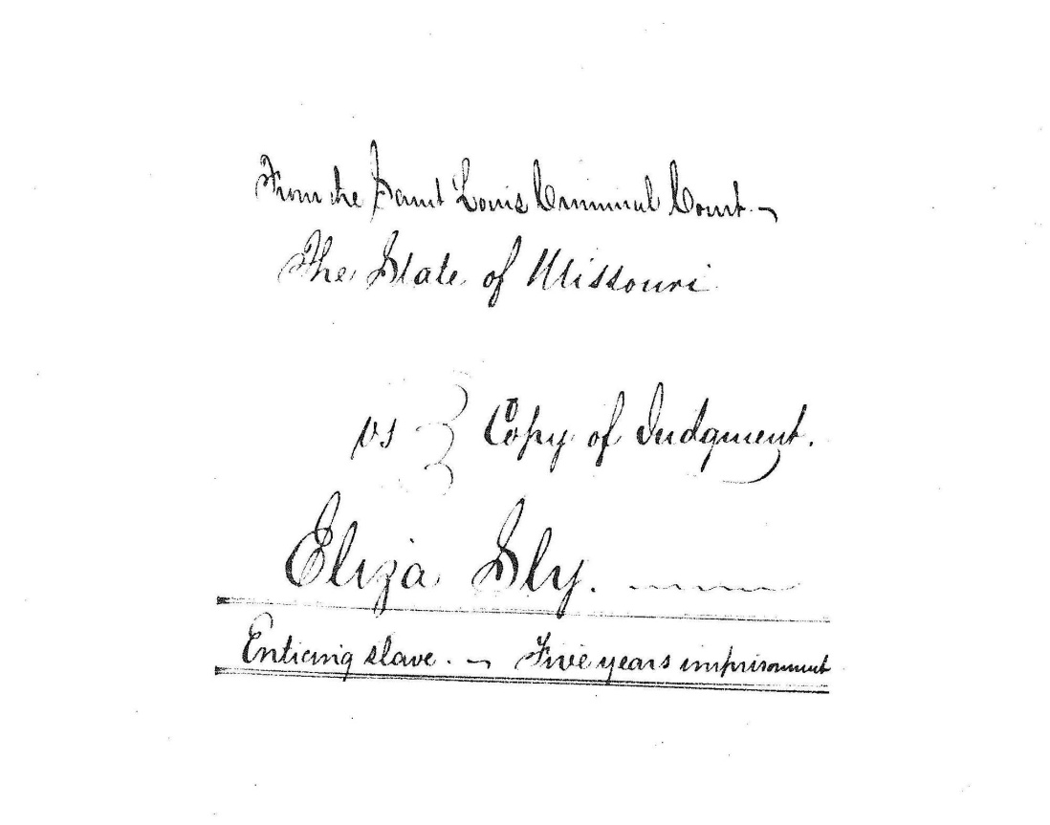
STUDENT ACTIVITY
St. Louis Circuit Court document recording the verdict in the case of State of Missouri vs. Eliza Sly

STUDENT ACTIVITIES III

1. The people described in this Reading were willing to go to jail for their beliefs. Select a current cause for which you might be willing to go to jail. Write a short essay explaining:
- what the cause is,
- what activists have already done, and
- what students in your school might do to help.
2. Create a poster that shows the importance of one of the people featured in the Reading. The use of color and neatly lettered captions should highlight important ideas and events.

STUDENT READING IV
German Abolitionists and the Power of the Press

During the 1830s and 1840s the states of Germany experienced a series of failed revolutions. Germany was not yet a united country, but instead a loose group of independent states ruled by nobles. Young university students across Germany were inspired by the promise of liberty for all in the American and French Revolutions. They formed societies which sought to end the power of the nobles and create democratic states. Membership in these societies were considered to be treason. So many the students and their families were eventually forced to leave Germany and seek freedom in America. Many Germans came to Missouri, as St. Louis was seen as the "Gateway to the West." Missouri had cheap available farm land for German farmers. Missouri’s growing cities and towns provided an opportunity to early a living as a craftsman, business owner, lawyer, minister, or newspaper publisher.
By the 1850s, German immigrants were the largest minority in St. Louis. They established schools, churches, and newspapers which continued to use the German language. Because they had fled repression at home, most of these immigrants were strongly against the institution of slavery.
One of these German immigrants who played an important role in the anti-slavery movement was Arnold Krekel. Trained as a lawyer, he settled in St. Charles County. Krekel operated several German language newspapers published in St. Charles. He also became a leader of the Union Home Guard during the Civil War and was appointed to be the Federal judge for Western Missouri by Abraham Lincoln. Krekel's newspapers gathered support for the anti-slavery wing of the Republican Party. In 1864, the Missouri legislature called for a convention in St. Louis to revise the Missouri Constitution. The convention selected Arnold Krekel to be its chairman. One of the many constitutional changes was the abolition of slavery in Missouri. This change was adopted in January of 1865, eleven months before the 13th Amendment to the U.S. Constitution abolishing slavery across the rest of the nation was ratified. That U.S. Constitutional amendment had been written and introduced by another Missourian, Representative John Brooks Henderson of Pike County.
After his appointment as a federal judge, Krekel moved to Jefferson City, Missouri. In 1866 he began working with African-American veterans to establish a university. Former members to the 62nd United States Colored Troops raised over $5,000 toward the establishment of Lincoln Institute. This became the first Missouri school of higher education for African-Americans. In 1921, the Institute became Lincoln University. While serving as a judge, Krekel also taught law at the Institute.
Another German immigrant to St. Charles County was Frederich Muench of Augusta. He was a minister who helped organize an immigration society in the city of Geissen, Germany. Its members pooled their money to pay for transportation to Missouri and to purchase land on which they settled. Muench settled in Augusta, Missouri.
Like Krekel, Frederich Muench was strongly abolitionist. He wrote articles against slavery. These were published in newspapers in St. Louis, St. Charles, and Hermann, such as the Anzeige des Westens and the Hermanner Wochenblatt. In 1856, he joined fellow revolutionary Frederich Hecker for an anti-slavery speaking tour of the Midwest. In 1861, he was elected to the Missouri State Senate. One of Muench's sons died in the Civil War Battle of Wilson's Creek while serving under German-American General Franz Sigel.
Many German immigrants volunteered for service in the Union Army after reading articles by Krekel and Muench. German-speaking newspaper editors such as Carl Strehly, Eduard Muhl, and Heinrich Boernstein used their newspapers to oppose slavery in Missouri. The power of the press called many young men to fight for the Union and oppose the enslavement of African-Americans.

STUDENT ACTIVITIES IV

The German language newspapers carried many editorials supporting the abolition of slavery. These newspapers are available online at https://chroniclingamerica.loc.gov/newspapers/. The articles are in German and the type is often difficult for students to read.
Go to the linked Library of Congress database and select Missouri newspapers. Check if there are any newspapers from your county printed prior to 1865.
1. Write a “Letter to the Editor” to one of the early newspapers printed in your county. Use the name of the newspaper and choose an appropriate date for your letter. Explain why you think people in your area should be opposed to slavery. What would you recommend people do to end slavery? The letter should be neatly written in ink or typed and two or three paragraphs in length.
2. Find articles or ads in the Missouri dealing with enslaved persons. Use them to make a mini-poster about the attitude of this newspaper toward enslaved persons. The newspapers on the Library of Congress site are in PDF format, but if your computer has a PDF Reader you can "take a snapshot" of just the section of the page dealing with slavery and then past them into a Word or Publisher document. This can then be printed and then cut to paste on your mini-poster. Attach a short paragraph explaining whether you think this newspaper is pro-slavery or pro-abolition.
3. Write an obituary for a specific Missouri newspaper about one of the people in the Reading or an imaginary German immigrant.
4. The following article appeared in the Salt River Journal published in Bowling Green Missouri on 18 July 1840 on page 2. Analyze this article. Is the article for against abolition? What action does the author wish his readers to take concerning abolition of slavery?
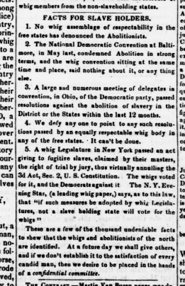

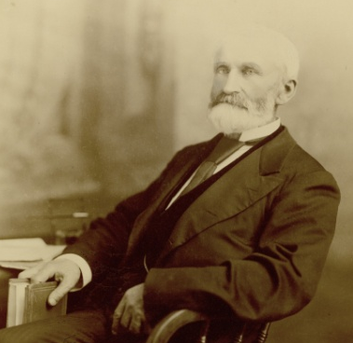
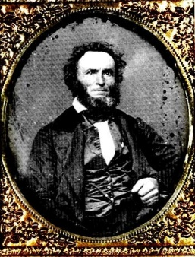
Arnold Krekel
https://mohistory.org/collections/item/resource:156354

Frederick Muench
mo-germans.com

STUDENT READING V
The Underground Railroad in Missouri

Abolitionists often became part of the Underground Railroad. They helped enslaved persons flee to a state where others would help them escape to Canada. There were no trains on the Underground Railroad, just a series of "depots". Those were places where an enslaved person could be hidden and fed. At each "depot" there would be a guide who would take the enslaved persons at night to the next "depot" until they reached safety. Safety could be Canada or a remote area of the U.S. where they could live without fear of being returned to a slave state.
In many states north of the Ohio River, the routes of the Underground Railroad are well documented. The houses and barns used to house escaping enslaved persons are now state or national historic sites. We can document a few regular routes which enslaved persons used to escape. One example is the route to Iowa from Lancaster, Missouri. We can discover many more routes in the trial documents of people who were arrested helping enslaved persons cross to free territory.
In1853 Francis Moss was charged with "Enticing Slaves to Escape" in Boonville, Missouri. The trial testimony shows Mr. Moss gave names and other information on members of the Underground Railroad in his area. Other court records and newspaper accounts tell of enslaved persons escaping across the Mississippi River to "safe houses" in East St. Louis, Quincy, and Brighton, Illinois.
The route to Quincy was first developed by Presbyterian Minister David Nelson. He had moved from Kentucky to open Marion College just outside Palmyra in northeast Missouri. Nelson was an abolitionist who traveled throughout eastern Missouri preaching about the evils of slavery. In St. Louis, after hearing a sermon by Rev. Nelson, Elijah Lovejoy joined the abolitionist cause. By 1836, pro-slavery men in Marion County had run Nelson out of Missouri. At the time, Dr. McPheeters was visiting his brother Samuel who taught at Marion College and wrote the letter quoted at the beginning of this curriculum.
Being forced out of Missouri did not stop Reverend Nelson's abolitionist activities. He only went as far as Quincy, Illinois, where he opened a new school named the Mission Institute. By 1839, students from Mission Institute were said to make night patrols along the Missouri bank of the Mississippi River between Palmyra and Hannibal looking for runaway slaves to help. The students had boats to take the runaways to Illinois and to a "depot" on the Underground Railroad, a red barn sixteen miles east of Quincy.
In 1841, three of the Mission students were arrested during an attempt to convince a group of enslaved persons to escape to Illinois. George Thompson, James Burr, and Alanson Work were arrested for Grand Larceny. Crowds of pro-slavery people gathered around the Palmyra jail almost nightly as they waited for the trial of the three young men. For safety, the trial was moved to the Circuit Court in St. Louis. All three were convicted and sent to the State Prison in Jefferson City.

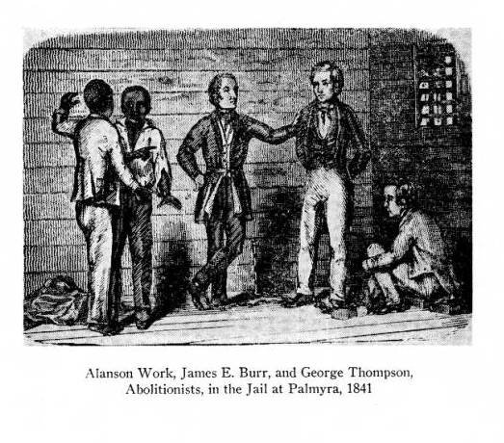
Each of the students was sentenced to twelve years in prison, but Work and Burr received pardons from Missouri Governor Edwards in 1845. Thompson was pardoned the next year. In 1847, Thompson published a book about his arrest and time in prison, Prison Life Reflections. After completing his training as a minister, Thompson became a Presbyterian missionary in West Africa.
A year after Thompson, Work, and Burr were arrested, a pro-slavery mob from Marion County crossed the frozen Mississippi River to Quincy during the night and burned the buildings of the Mission Institute. Nelson rebuilt them and continued his abolitionist activities. Enslaved persons continued to cross the river and make their way to the house of Dr. Richard Eells, a known abolitionist, or to that red barn sixteen miles east of Quincy. In 1853, local papers noted that eleven enslaved persons from farms near Palmyra had escaped as a group to Quincy and then to freedom.
Neither arrests nor mobs stopped the flow of enslaved persons out of the state. After the death of her husband, Mary Meachum, wife of the Reverend John Berry Meachum, continued to use her home as a "safe house" on the Underground Railroad. Living on Fourth Street, she was just blocks from the Mississippi River. In 1851, eleven enslaved persons had gathered at her home and waited until dark to make their way to the river where a boat was waiting to take them to Illinois. Unfortunately, they were caught. Mary and her helper, a freedman named Isaac, were arrested. In July of 1851, Mary Meachum was charged with Slave Theft. The case went before a jury which acquitted her of one charge and dismissed all the other charges against her and Isaac.
Eighteen years later, Mary Meachum died in St. Louis. He husband had been buried in Bellefontaine Cemetery, but the gravesite of Mary is unknown. In 2001, the National Park Service dedicated the Mary Meachum Crossing Park near the site of her 4th Street house. Today it has a visitor's center and hosts a yearly celebration of the work of Mary and other Missourians who opposed slavery.
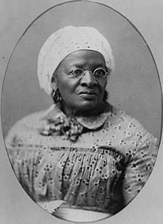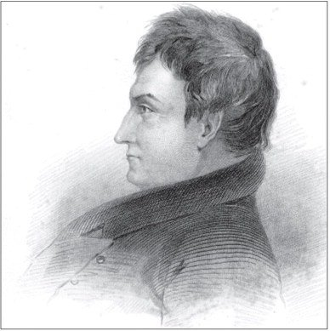
Rev. David Nelson. Historical Society of Quincy and Adams County
Mary Meachum
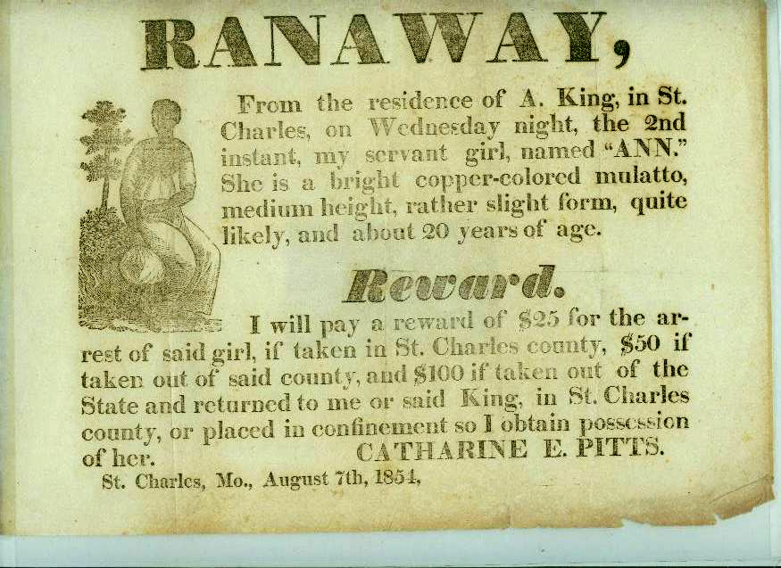

STUDENT ACTIVITIES V

1. In many of the states north of the Ohio River, markers were placed near sites of the Underground Railroad to help slaves who were seeking shelter and food. These signs were often "in code," so others did not suspect that the persons living there were part of the Underground Railroad. In some southern states, slaves made quilts which could be hung on the line "to dry" as sign to passing escapees that this was a "safe house." The choice of different patterns in a quilt gave messages to enslaved persons who knew the "code" about what to do as they passed through the local area. Here is one "code" which was used:
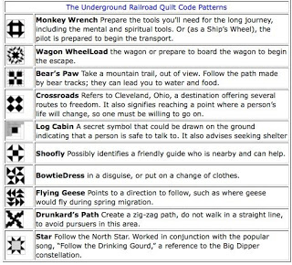

Devise a six square "freedom quilt" which you could hang outside your bedroom window as a message to people traveling along the Underground Railroad. Below your quilt, give the meaning of the symbols you have used. Create your own "code."

2. Abolitionist groups often produced flyers which were posted in public to warn African-Americans against "slave catchers." Many of these signs, like the own below, were "written signs”. Many former enslaved persons could not read because they had been denied an education. Today, we often produce signs such as road signs, bathroom signs, etc. which can be understood by people no matter what language they speak or if they cannot read.
Use the information from the sign below to create a new sign with only symbols which would provide the same message. On a separate sheet, explain what the images or symbols mean.

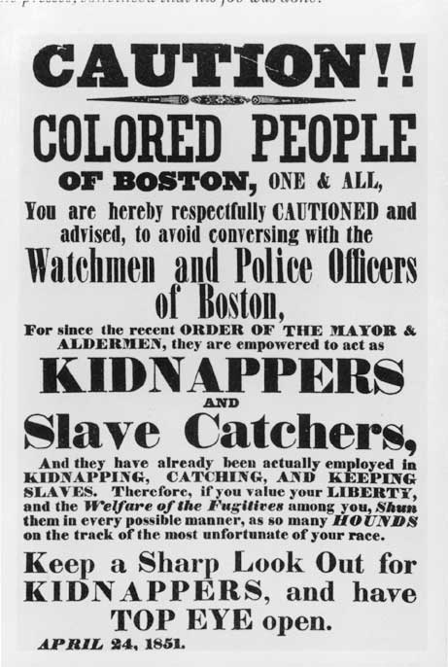

https://lostmuseum.cuny.edu/archive/caution-colored-people-of-boston
3. Create a well-written closing argument for the defense of someone arrested in the 1850s for helping an enslaved person flee on the Underground Railroad. Research the Fugitive Slave Act of 1850 and the Underground Railroad as part of your planning. Write neatly in ink or type your two to three paragraph argument.
4. Using research on the Fugitive Slave Act of 1850 and the Underground Railroad as part of your planning. Then write a paragraph describing the dangers and activities that might be faced by an enslaved person seeking freedom by using the Underground Railroad.

SOURCES

Anhorn, Reg. “Rev. Nelson and Abolition come to Quincy.”
Historical Society of Quincy and Adams County.
23 Dec. 2012. Online.

Bellemy, Donnie. “Free Blacks in Antebellum Missouri 1820-1860.
Missouri Historical Review Vol. 67: (January 1973), 198-226.

Blum, Virgil C. “The Political and Military Actions of the German
Element in St. Louis 1859-1861.” Missouri Historical Review
Vol. 42: (January 1948), 103-129.
Ehlmann, Steve. Crossroads: a History of St. Charles County,
Missouri. St. Charles: Lindenwood University Press, 2004.

“Historic Missourians.” State Historical Society of Missouri. Online.
//historicmissourians.shsmo.org

Lee, George. “Slavery and Emancipation in Lewis County, Missouri.”
Missouri Historical Review. Vol. 65:3 ( ), 294-313.

Lee, George. Slavery North of St. Louis. Canton, MO: Lewis County
Historical Society, .

Merkel, Benjamin. “The Abolitionist Aspect of Missouri’s Anti-Slavery
Controversy.” Missouri Historical Review Vol. 44:3 (April 1971),
232-253.

Merkel, Benjamin. “The Underground Railroad and the Missouri
Borders.” Missouri Historical Review Vol. 37: (April 1943)
271-285.

McPheeters, William. Letter to Margaret Robb. 12 June 1836.
McPheeters Papers, Missouri Historical Society Research
Center, St. Louis.

Meyer, Duane. The Heritage of Missouri: A History. St. Louis:
State Publishing Co., 1970.

Norton, Sydney. German Immigrant Abolitionists Fight for a Free
Missouri. NP: St. Louis University Center for Global Citizenship
and the Deutschheim State Historic Site, 2016.

Richardson, William A. Dr. David Nelson and His Times. Internet
Archives.

Roloff, Peter and others. Utopia: Revisiting a German State in America.
Bremen, Germany: Edition Falkenberg, 2013.

Shaffar, Mikelle. "Aunt Sina." St. Charles Heritage. (April 1995) 50-54.

State Historical Society of Missouri. “Famous Missourians.” Online.

